Name: Benjamin Prud’homme

Batch: LISUM12

Date: September 4, 2022

Submitted to: Data Glacier

Deployment on Heroku

**Step 1: Download Iris dataset**

* Features: SepalLength, SepalWidth, PetalLength, PetalWidth
  + All floats, in inches
* To predict: Species (Iris-setosa, Iris-versicolor, Iris-virginica)

**Step 2: Build ML classification model (model.py)**

**Step 3: Write Flask app (app.py)**

**Step 4: Create Procfile**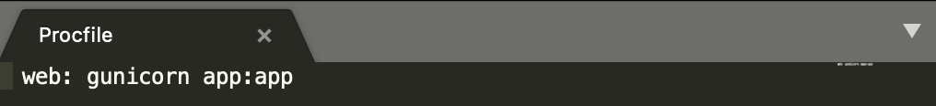

**Step 5: Create requirements.txt**

**Step 6: Create runtime.txt to force Python 3.9.13 (the version that’s on my local device)**

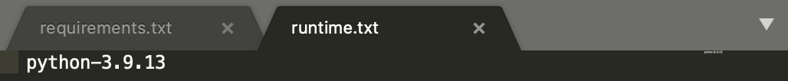

**Step 7: Upload to github (iris-classification-bprudhomme**

**Step 8: Create Heroku account (not pictured)**

**Step 12: Test model**

